Experiment 13: ultrasonic distance measuring module
This module has stable performance, accurate measurement range, and can be compared with foreign SRF05, SRF02 and other ultrasonic ranging module. Module high precision, blind area (2cm) ultra near, stable ranging is the product of this product successfully to the market!
Experimental components
Arduino control board *1

USB line *1

Ultrasonic *1
Main technical parameters: the use of voltage: DC5V, static current: less than 2mA level output: high 5V, level output: bottom 0V, induction angle: no more than 15 degrees, detection range: 2cm-450cm, high accuracy of up to 0.2cm

Connection mode, VCC, trig (control side), echo (receiver), GND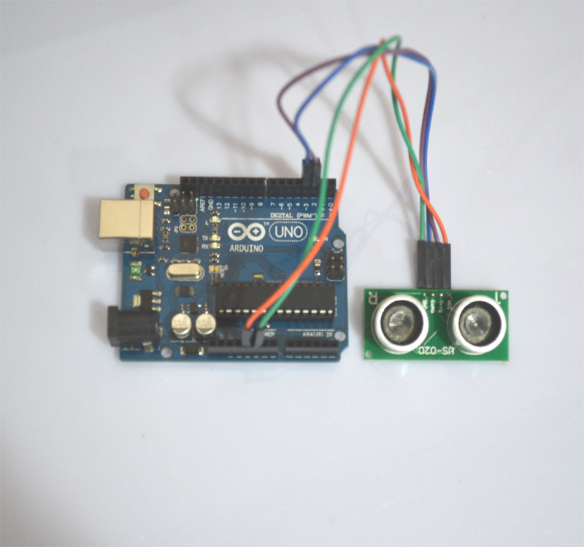

Note:1.the module should not be charged connection, if you want to live connection, let the first module of the GND connection, otherwise it will affect the normal operation of the module.

2, ranging, the area of the measured object is not less than 0.5 square meters and the plane as far as possible to level, otherwise the results of the measurement.

Program source code：
const int TrigPin = 2;
const int EchoPin = 3;
float cm;
void setup()
{
Serial.begin(9600);
pinMode(TrigPin, OUTPUT);
pinMode(EchoPin, INPUT);
}
void loop()
{
digitalWrite(TrigPin, LOW); //Low high and low level to send a short pulse to TrigPin
delayMicroseconds(2);
digitalWrite(TrigPin, HIGH);
delayMicroseconds(10);
digitalWrite(TrigPin, LOW);
cm = pulseIn(EchoPin, HIGH) / 58.0; //The echo time is converted into cm
cm = (int(cm * 100.0)) / 100.0; //Keep two decimal places
Serial.print(cm);
Serial.print("cm");
Serial.println();
delay(1000);
}

After testing the code, this experiment will come to an end.

